IT 328 Full Stack Development Final Project Proposal

Marcos Rivera Taras Gorbachevskiy

Title: The Daily Tech

Description: Tech Blog/Forum Website

An online forum and news related website that allows a signed in user to create a post, edit, and remove their own post. A post will consist of header, a required image the user needs to upload for a banner and the article itself. The focused content is tech related such as housewares, mobile and etc.

Class Diagram:

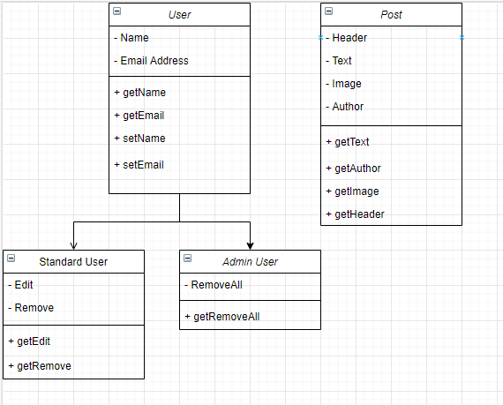

ER Diagram:

User can have many posts

Relationship is one-to-many

